Program:
# -------------------------------
# Spam Email Classifier using Logistic Regression
# -------------------------------

# Step 1: Import Libraries
import pandas as pd
from sklearn.model_selection import train_test_split
from sklearn.feature_extraction.text import TfidfVectorizer
from sklearn.linear_model import LogisticRegression
from sklearn.metrics import accuracy_score, classification_report

# Step 2: Create Sample Dataset
data = {
'Email': [
'Win money now!!!',
'Congratulations! You have won a prize!',
'Claim your free voucher today',
'Meeting scheduled at 3 PM',
'Please find the attached report',
'Let’s catch up for lunch tomorrow',
'Exclusive offer just for you, win big!',
'Your account has been updated successfully',
'Reminder: project submission tomorrow',
'Get a free gift card now'
],
'Label': [
'spam', 'spam', 'spam',
'not spam', 'not spam', 'not spam',
'spam', 'not spam', 'not spam', 'spam'
]
}

# Convert to DataFrame
df = pd.DataFrame(data)

# Step 3: Split data into input (X) and output (y)
X = df['Email']
y = df['Label']

# Step 4: Convert text data into numeric form using TF-IDF
vectorizer = TfidfVectorizer(stop_words='english', lowercase=True)
X_features = vectorizer.fit_transform(X)

# Step 5: Split the dataset into training and testing sets
X_train, X_test, y_train, y_test = train_test_split(
X_features, y, test_size=0.3, random_state=42
)

# Step 6: Train the Logistic Regression Model
model = LogisticRegression()
model.fit(X_train, y_train)

# Step 7: Make Predictions on the Test Set
y_pred = model.predict(X_test)

# Step 8: Evaluate the Model
print("Model Accuracy:", round(accuracy_score(y_test, y_pred) * 100, 2), "%")
print("\nClassification Report:")
print(classification_report(y_test, y_pred))

# Step 9: Test with New Emails
test_emails = [
"Get free cash now!",
"Your meeting is rescheduled to 5 PM",
"Win a brand new phone instantly",
"Can we discuss the assignment later?"
]

# Convert test emails into features
test_features = vectorizer.transform(test_emails)

# Predict Results
predictions = model.predict(test_features)

print("\n--- New Email Predictions ---")
for email, label in zip(test_emails, predictions):
print(f"Email: '{email}' --> Prediction: {label}")
OUTPUT:
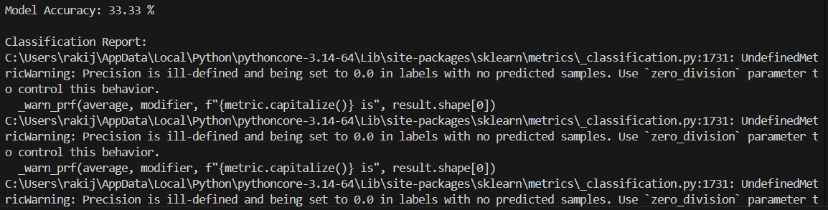
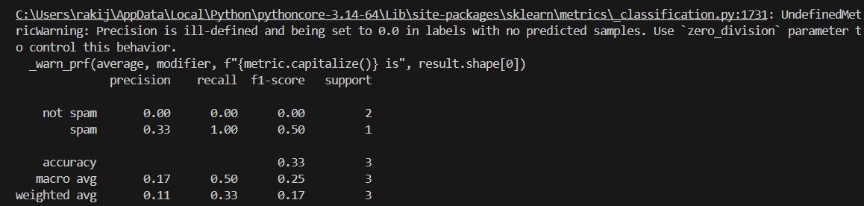
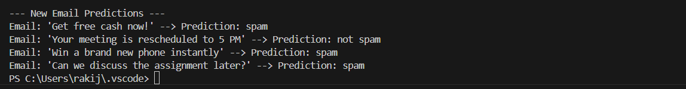
Result:
Thus the program of implmetaion email spam classifer using logistic regresions implemented with conditions and successfully implemented

